MODULE -1
Q.1 Write a simple "Hello World" program in two different programming languages of your choice. Compare the structure and syntax?
Ans. In Java :
public class learn {
public static void main(String[] args) {
System.out.println("Hello World!");
}
In C:
#include<stdio.h>
void main(){
printf("Hello world);
}
Q2. Research and create a diagram of how data is transmitted from a client to a server over the internet?
Ans.
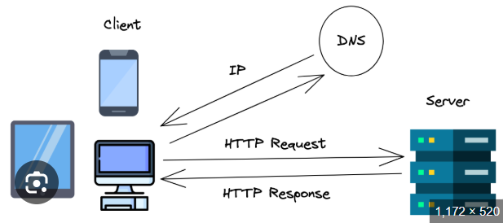

Q.3 Design a simple HTTP client-server communication in any language?
Ans. 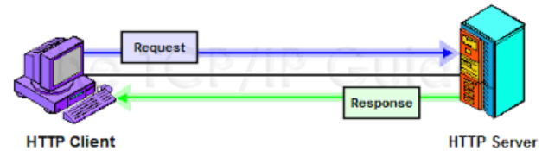

Q.4 Research different types of internet connections (e.g., broadband, fiber, satellite) and list their pros and cons?
Ans.
Type | Pros | Cons
DSL | Cheap, uses phone line, widely available | Slower, speed drops with distance
Cable | Fast, good for streaming & gaming | Shared bandwidth, upload slower
Fiber | Very high speed, low latency, future-proof | Limited availability, costly install
Wireless | Easy setup, works in rural areas | Weather/signal issues, less stable
Satellite | Works anywhere, good for remote areas | Expensive, high latency, weather issues
Mobile (4G/5G) | Portable, fast (esp. 5G), easy setup | Data caps, speed depends on coverage

Q.5 Simulate HTTP and FTP requests using command line tools (e.g., curl).
Ans.
HTTP:-
- GET Request:-
curl http://example.com
FTP:-
- List Files on FTP Server
curl ftp://ftp.example.com/

Q.6 Identify and explain three common application security vulnerabilities. Suggest possible solutions
Ans.

3 Common Application Security Vulnerabilities
- SQL Injection (SQLi)
  - Issue: Malicious SQL in input → database hacked.
  - Fix: Use prepared statements, sanitize input.
- Cross-Site Scripting (XSS)
  - Issue: Malicious script runs in user’s browser.
  - Fix: Escape/validate input, use CSP.
- Cross-Site Request Forgery (CSRF)
  - Issue: User tricked into unwanted actions (like money transfer).
  - Fix: Use CSRF tokens, SameSite cookies.

Q.7 Identify and classify 5 applications you use daily as either system software or application software?
Ans.

Five applications I use daily and their classification
- Microsoft Word → Application Software (used for creating and editing documents).
- Google Chrome → Application Software (used for browsing the internet).
- WhatsApp (Desktop/Web) → Application Software (used for communication and messaging).
- Windows Operating System → System Software (manages computer hardware and provides a platform for applications).
- Audio Driver → System Software (enables communication between the operating system and sound hardware).

Q.8 Design a basic three-tier software architecture diagram for a web application?
Ans.
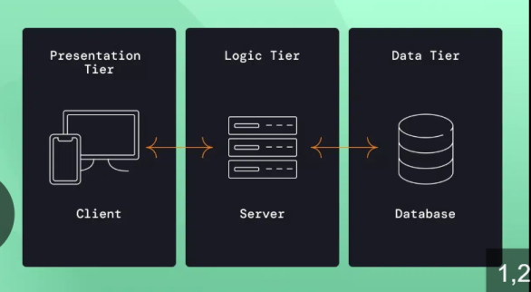
Q.9 Create a case study on the functionality of the presentation, business logic, and data access layers of a given software system?
Ans.

Case Study: Online Food Ordering System

1. Presentation Layer (UI)
- User interface (web/app).
- Shows menus, takes input (login, orders, payment).
- Tech: HTML, CSS, JS, React.

2. Business Logic Layer
- Handles rules & processing.
- Validates login, calculates bills, manages orders.
- Tech: Java, Node.js, Python, .NET.

3. Data Access Layer
- Stores and retrieves data.
- Keeps user info, restaurant menu, orders, payments.
- Tech: MySQL, MongoDB, PostgreSQL.
Workflow: User orders → Business Layer checks & processes → Database stores order.
Conclusion: 3-tier = UI + Logic + Data → organized, secure, scalable.

Q.10 Explore different types of software environments (development, testing, production). Set up a basic environment in a virtual machine?
Ans.
Q.11 Write and upload your first source code file to Github?
Ans. There are screenshot that I made 2 word of practical and theory I write a code in this two word file:-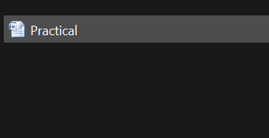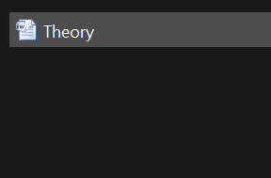
Uploads:-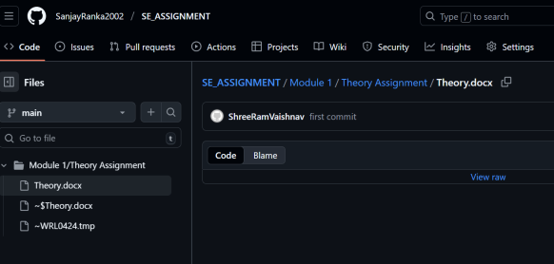

Q.12 Create a Github repository and document how to commit and push code changes?
Ans.Git repo that I have made already:- in this repo it have a one folder that is module and I have write a code in this two word and after write a code intilize git by git bash and add origin after git add command use ,git commit command use and push in origin.
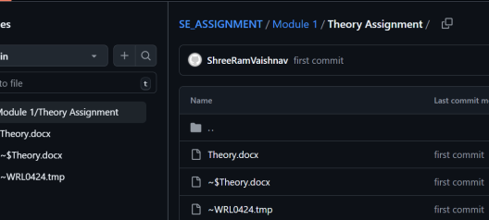
Q.14 Create a student account on Github and collaborate on a small project with a classmate?
Ans.

Q.15 Create a list of software you use regularly and classify them into the following categories: system, application, and utility software?
Ans.
- Microsoft Word → Application Software (used for creating and editing documents).
- Google Chrome → Application Software (used for browsing the internet).
- WhatsApp (Desktop/Web) → Application Software (used for communication and messaging).
- Windows Operating System → System Software (manages computer hardware and provides a platform for applications).
- Audio Driver → System Software (enables communication between the operating system and sound hardware).

Q.16 Follow a GIT tutorial to practice cloning, branching, and merging repositories?
Ans.
Clone a Repository:-
Ex- git clone https://github.com/octocat/Hello-World.git.
Create a New Branch:-
Ex- git checkout -b my-feature.
Merge Branches
Ex- git merge my-feature
Q.17 Write a report on the various types of application software and how they improve productivity?
Ans.
Q.18 Create a flowchart representing the Software Development Life Cycle (SDLC).
Ans.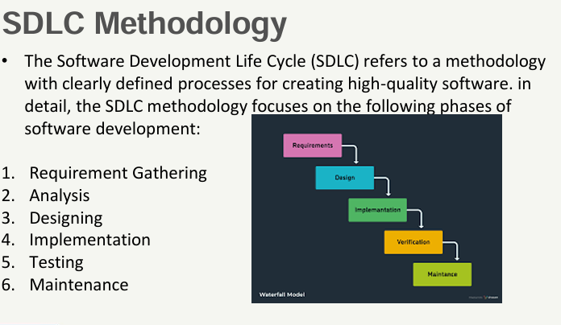
Q.19 Write a requirement specification for a simple library management system?
Ans.

Requirement Specification – Library Management System

1. Introduction
The system manages books, users, and borrowing/returning activities in a library.

2. Functional Requirements
- User Management:
  - Add/update/delete members.
  - Manage login (admin, librarian, member).
- Book Management:
  - Add/update/delete books.
  - Search books by title, author, subject.
- Transaction Management:
  - Issue and return books.
  - Track due dates and fines.
  - Maintain borrowing history.

3. Non-Functional Requirements
- Usability: Easy-to-use interface.
- Security: Only authorized users can manage books/transactions.
- Performance: Quick search and fast transactions.
- Scalability: Should support more users/books in the future.

Q.20 Perform a functional analysis for an online shopping system?
Ans.

Functional Analysis – Online Shopping System

Main Functions
- User Management
  - User registration, login, profile update.
- Product Management
  - Browse/search products.
  - View product details (price, description, reviews).
- Shopping Cart
  - Add/remove/update items.
  - View total cost.
- Order Management
  - Place orders.
  - Track order status (pending, shipped, delivered).
- Payment Management
  - Secure payment (cards, UPI, wallets).
  - Generate receipts.
- Admin Functions
  - Manage products, categories, stock.
  - View sales reports.

Q.21 Design a basic system architecture for a food delivery app?
Ans.
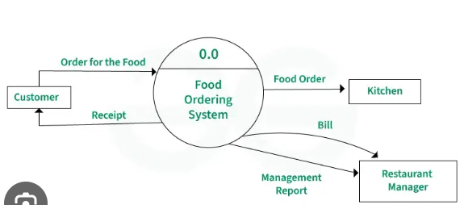
Q.22 Develop test cases for a simple calculator program?
Ans. Test Cases:-
- First We take two or more inputs and one operator this operator perform operation.
- Second We Put some conditions of like sum ,sub ,mul and div that put inputs in it.
- After switch case perform and we got some output that we call.
Q.23 Document a real-world case where a software application required critical maintenance?
Ans.
Q.24 Create a DFD for a hospital management system?
Ans.
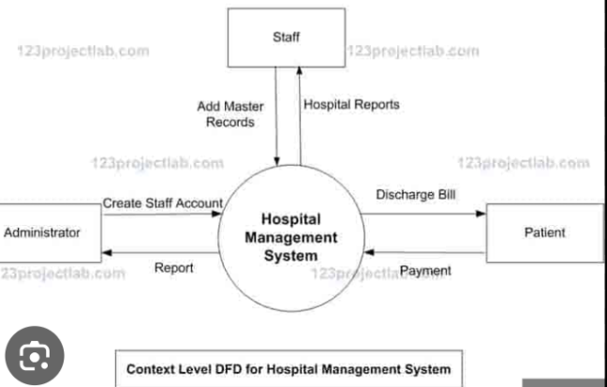
Q.25 Build a simple desktop calculator application using a GUI library?
Ans.
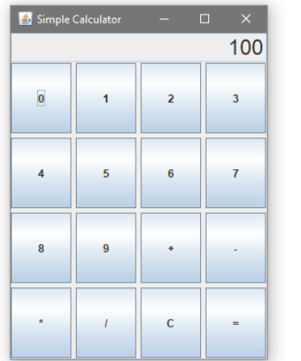

Q.26 Draw a flowchart representing the logic of a basic online registration system?
Ans.





